CURRICULUM VITAE
PERSONAL PROFILE
-----------------------------------------------------------------------------------------------------------------------------------------
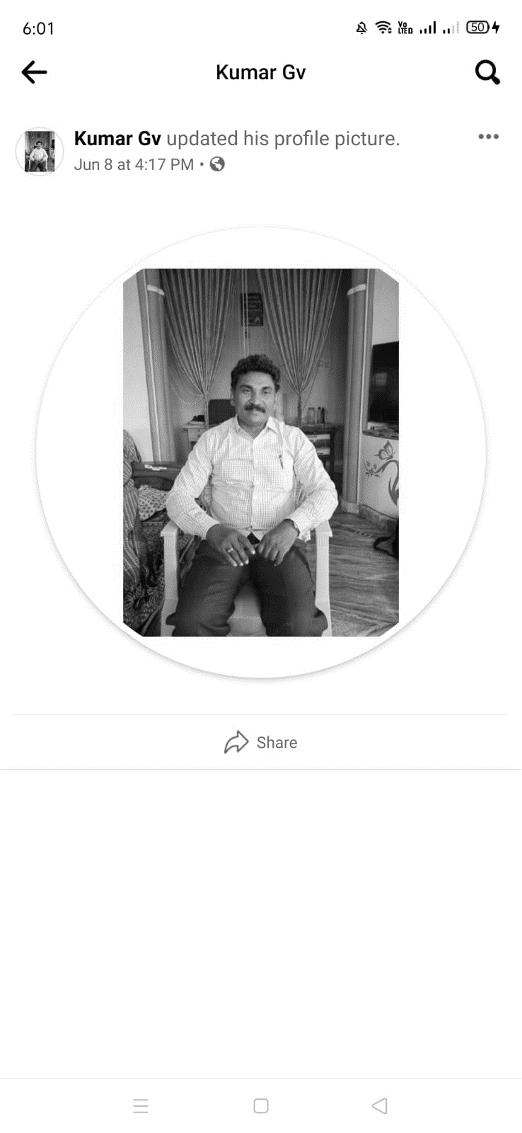
Sri T. Madanna, MA, M.Ed, SLET, (PhD).,
Lecturer in Economics,
Government College for Men, Kurnool,
Constituent College of Cluster University,
Kurnool – 518004 (AP)
Email: thamadapallimadanaa@gmail.com
Mobile: 9441311130
Date of Birth: 01.07.1969
Languages known: Telugu, English, Hindi.
-----------------------------------------------------------------------------------------------------------------------------------------
ACADEMIC PROFILE
-----------------------------------------------------------------------------------------------------------------------------------------
SN | Qualification | Specialization | % of Marks | College/University | Year
1 | SSC | General | 55 | Govt. Boys High School, Atk | 1986
2 | Intermediate | HEC | 58 | Govt Jr. College, Atmakur | 1988
3 | BA | HEP | 62 | SJGC, Kurnool | 1991
4 | MA | Economics | 58 | S V University, Tirupati | 1993
6 | SLET | Economics | --- | APCSC, HYD | 1997
6 | MEd | Education | 56 | SV University, Tirupathi | 1996
7 | PhD | Labour Economics | --- | SV University | Perusing
-----------------------------------------------------------------------------------------------------------------------------------------
PROFESSIONAL PROFILE
-----------------------------------------------------------------------------------------------------------------------------------------
Date of initial appointment as Junior College Lecturer : 22.01.2002
Date of appointment as Degree College Lecturer : 05.11.2010
College where appointed : GDC, Uravakonda, Anantapur
SN | Serviced as | College | From | To | Years
1 | DL | GDC, Uravakonda, Atp | 2010 | 2013 | 3
2 | DL | GDC, Nandyala | 2013 | 2016 | 3
3 | DL | GDC, Nandikotkur | 2016 | 2021 | 5
4 | DL | GDC (M), Kurnool | 2021 | till | 1

Total teaching experience : Inter-9, Degree -11, Total – 21 Years

-----------------------------------------------------------------------------------------------------------------------------------------
COURSES ATTENDED
-----------------------------------------------------------------------------------------------------------------------------------------
SN | COURSE | ORGANISED BY | PLACE | GRADE OBTAINED | YEAR
1 | OC | ASC, SV University | Tirupati | A | 2018
2 | RC-Economics | ASC, Osmania University | Tirupati | A | 2011
3 | RC-Economics | ASC, SV University | Tirupati | A | 2020
4 | RC-Economics | NPTEL-SWYAM | online | B | 2021
5 | Workshop | KVR (W) | Kurnool | --- | 2006
6 | FDP in LMS | APCCE, Vijayawada | Online | --- | 2020
7 | FDP in Economics | APCCE, Vijayawada | Online | --- | 2021
-----------------------------------------------------------------------------------------------------------------------------------------
PROFESSIONAL EFFICIENCY & RESEARCH
-----------------------------------------------------------------------------------------------------------------------------------------
Articles published : 02 articles in National Journals.
Seminars – Paper presentation : 5 Papers
-----------------------------------------------------------------------------------------------------------------------------------------
ADDITIONAL RESPONSIBILITIES & ABILITIES
-----------------------------------------------------------------------------------------------------------------------------------------
In-charge of the Department of Economics : From 2021.
Faculty Development Council : President
Staff-club : President
Discipline Committee : Member
Admission Committee : Member

******

